**[](http://www.sqlshack.com/)**

[Skip to content](http://www.sqlshack.com/dba-guide-sql-server-performance-troubleshooting-part-2-monitoring-utilities/#content)

Top of Form

[http://www.sqlshack.com/wp-content/themes/sqls/images/new_icons/twitter-01.png](https://twitter.com/SQLShack) [http://www.sqlshack.com/wp-content/themes/sqls/images/new_icons/facebook-01.png](https://www.facebook.com/SQLShack) [http://www.sqlshack.com/wp-content/themes/sqls/images/new_icons/gplus-01.png](https://plus.google.com/u/0/+SQLShack/posts) [http://www.sqlshack.com/wp-content/themes/sqls/images/new_icons/feed-01.png](http://www.sqlshack.com/feed/)



Bottom of Form



A DBA guide to SQL Server performance troubleshooting – Part 2 – Monitoring utilities

March 13, 2014   by [Milena Petrovic](http://www.sqlshack.com/author/milenapetrovic/)

In this article, we will present native Windows and SQL Server tools commonly used for troubleshooting SQL Server performance issues. Selecting the right performance monitoring utility depends on your monitoring goals and coding knowledge, as the tools provide different information and have different analysis capability

**SQL Server Profiler**

SQL Server Profiler is a monitoring tool that you can use to create and manage SQL Server traces for monitoring SQL Server instance activity. These trace files can later be analyzed and replayed. Profiler has a graphical interface, which makes it easy to use

Besides auditing actions that happened on a SQL Server instance, it is useful for SQL Server performance troubleshooting, as it can track stored procedure and query execution and show the slow ones, capture statements and events that caused performance degradation, replay the specific set of events in another environment for testing purposes, etc.

To start SQL Server Profiler:

1. Open **Start, All Programs** (Windows + C for Windows 8)
2. Select **SQL Server Profiler**

Or

1. Open **SQL Server Management Studio**
2. From the **Tools** menu, select **SQL Server Profiler**

Or

1. Open **Command Prompt**
2. Type *profiler*
3. Press **Enter**

Now, you should create traces that will collect the information you need in order to monitor and troubleshoot SQL Server performance

To create a new trace:

1. In **SQL Server Profiler**, open **File** in the menu
2. Select **New Trace**
3. Select a SQL Server instance, Authentication Mode, and provide credentials
4. In the **Event selection** tab, click **Show all events**
5. Select the events and event columns you want to trace

To capture information about events that occur on a database, e.g. data and log files auto-grow and auto-shrink events, select these events in Database event type

[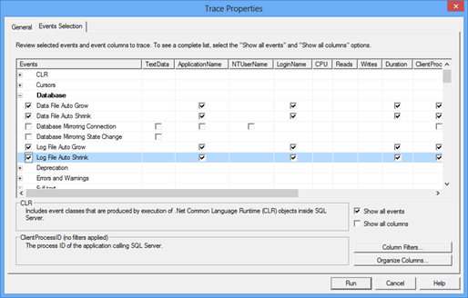](http://www.sqlshack.com/wp-content/uploads/2014/03/TraceProperties.png)

To trace various errors, such as CPU threshold exceeded, select this event in the **Errors and Warnings**EVENT type

1. In the **General** tab, select whether to save the trace to a file or to a table
2. Click **Run**

All events that belong to the event types selected for tracing will be captured

[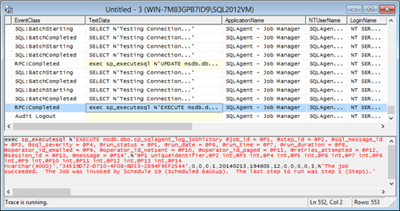](http://www.sqlshack.com/wp-content/uploads/2014/03/BatchStarting.png)

Although SQL Server Profiler provides a lot of useful information, some DBAs avoid using it on a production server, as it can add significant overhead. Also, if you haven’t configured SQL Server trace collection property to collect just the information you really need for analysis, there will be plenty of collected data which might be difficult to analyze

**Windows Performance Monitor**

Windows Performance Monitor is a monitoring tool shipped with Windows. It tracks various performance counters and monitors overall system and application performance. The counter values are shown in real-time graphs and can be saved in log files and used for later analysis

Windows Performance Monitor provides a wide range of counters. Monitoring too many counters will affect system performance and make analysis difficult, so it’s necessary to determine monitoring goals first, and then select the counters to monitor. A well-selected set of counters provides enough information for useful conclusions, quick diagnosis, and finding the problem origin, therefore efficient problem solving. Capturing too little or wrong counters will not provide enough information for useful conclusions, might be misleading and induce wrong conclusions

When it comes to selecting the counters, it’s necessary to understand what they represent, what are acceptable values, whether there is a threshold, or the value determined based on a trend line

To open Windows Performance Monitor:

* Open **Start, Run** (Windows + R for Windows 8), type **perfmon**, and press **Enter**
* Open **Control Panel, System and Security, Administrative Tools**, and click **Performance Monitor**

To add a counter:

1. Select **Add Counters** in the context menu, or click the **Add** icon in the menu
2. Select the computer you want to monitor
3. In the list of available counters, select the counter group e.g. *MSSQL$2012:Buffer Manager* and then *Lazy writes/sec*

[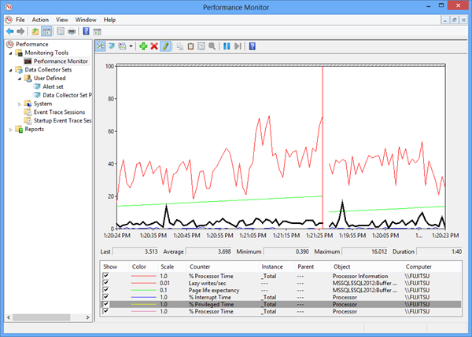](http://www.sqlshack.com/wp-content/uploads/2014/03/PerformanceMonitorPrivilegedTime.png)

Windows Performance Monitor shows useful information in comprehensive real-time graphs and can save historical data for a long time, so it can be used for later analysis. Its disadvantages are that it cannot provide sufficient information for deep analysis nor show a trend line or a threshold in the graph

**SQL Server Activity Monitor**

SQL Server Activity Monitor is a feature available in SQL Server Management Studio, useful for quick and basic SQL Server activity monitoring. It shows only information about the SQL Server processes and their effect on SQL Server performance

It shows *% Processor Time, Waiting Tasks, Database I/O,* and *Batch Requests/sec* in the **Overview** pane; the list of currently running processes on the SQL database in the **Processes** pane; the information about waits for resources in the **Resource Waits** pane; a list of all databases on the SQL Server instance along with information about the database files, their paths, and names in the **Data File I/O** pane, and the list of the queries recently executed that use most of memory, disk, and network resources in the **Recent Expensive Queries** pane

To start Activity Monitor, right-click the SQL Server instance in **Object Explorer** and select **Activity Monitor**

[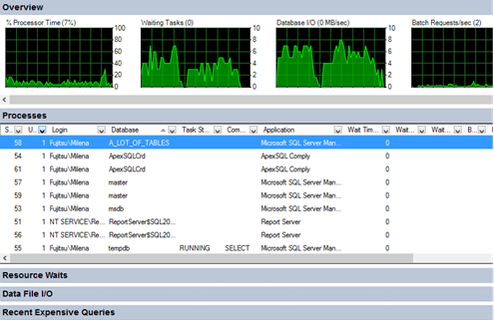](http://www.sqlshack.com/wp-content/uploads/2014/03/ActivityMonitorOverview.png)

Activity Monitor cannot provide data for deep investigation, store historical records for later analysis, nor can additional parameters be monitored

**SQL Server Data Collector**

SQL Server Data Collector is another SQL Server Management Studio feature that can be used for SQL Server performance monitoring and troubleshooting. It’s available in SQL Server 2008 and later. Data Collector can collect performance metrics on multiple SQL Server instances and store them in a single repository. Data is collected based on the specification used. There are three built-in specifications that provide automatic collection of the most common performance metrics – disk usage, query statistics, and server activity. Custom data collector specifications can be created, but it requires coding. Data collection is possible only if SQL Server Agent is running and Management Data Warehouse is configured

To open Data Collection reports

1. In SQL Server Management Studio **Object Explorer**, expand **Management**
2. Right-click **Data Collection** and select **Reports**
3. Select any of the available reports – **Server Activity History, Query Statistics History,** or **Disk Usage Summary**

[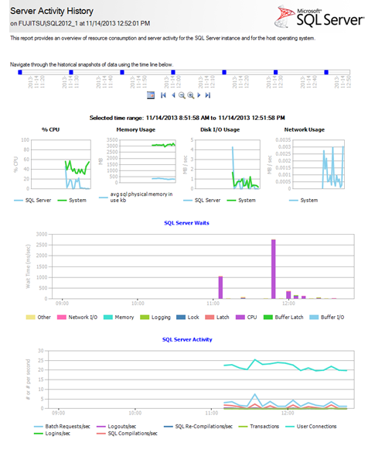](http://www.sqlshack.com/wp-content/uploads/2014/03/ServerActivityHistory.png)

**Dynamic Management Views (DMVs)**

Besides the monitoring utilities available in Windows and SQL Server Management Studio, Dynamic Management Views (DMVs) can also be used to monitor SQL Server performance and troubleshoot issues. These views are: sys.dm\_exec\_sessions, sys.dm\_os\_performance\_counters, sys.dm\_os\_memory\_brokers, sys.dm\_os\_memory\_nodes, sys.dm\_exec\_procedure\_stats, sys.\_dm\_os\_sys\_info, sys.dm\_exec\_requests, sys.dm\_exec\_requests, and many more

We’ll present only a few commonly used views for SQL Server performance monitoring in this article

*sys.dm\_exec\_sessions* – returns a row for every session on the queried SQL Server instance, along with details such as the name of the program that initiated the session, session status, SQL Server login, various time counters, and more

*sys.dm\_exec\_requests* – returns a row for every user and system request being executed on the SQL Server instance. To find the blocked requests, search for the requests where the status column value is ‘suspended’

*sys.dm\_exec\_query\_stats* – returns a row for every query statement in a cached query plan. It provides information about average, minimal, maximal, and total processor time used by the plan, along with other useful information for performance analysis

*sys.dm\_os\_performance\_counters*- returns a row for each SQL Server performance counter. It provides a quick way to find out current performance counter values. However, there are five counter types, and to be sure you’re interpreting the returned values correctly, you have to know how to calculate a value for each counter type. It’s easiest with the counter type 65792, as no calculation is needed. Counter types 1073874176, 537003264, and 272696576 require additional calculation in order to provide the metric current value

If the values are not properly calculated, they can be confusing, misleading, and lead to wrong conclusions

**SQL Server Extended Events**

SQL Server Extended Events allow collecting information useful for troubleshooting SQL Server performance issues. They enable finding the most expensive queries, latch, deadlock, and blocking causes, troubleshooting excessive processor usage, and more

To use Extended Events for performance monitoring, determine which events you want to monitor, and create a session using SQL Server Management Studio options, or T-SQL

To create the ReadWriteActivity session to capture event data for completed file reads and writes, and write it from the log cache file to the physical log file:



|  |  |
| --- | --- |
| 1  2  3  4  5  6  7 | CREATE EVENT SESSION ReadWriteActivity  ON SERVER    ADD EVENT sqlserver.file\_read\_completed,  ADD EVENT sqlserver.file\_write\_completed  ADD TARGET package0.asynchronous\_file\_target     (SET filename = 'c:\PerfLogs\ExtELog.xel', metadatafile = 'c:\PerfLogs\ExtELog.xem') |

After the session is created, to start it:

1. Expand **Management** in Object Explorer
2. Expand **Extended Events**
3. Expand **Sessions**
4. Find the Event Session, right-click it and select **Start**

To see the live event data with its details, select **Watch Live Data** from the event context menu in Object Explorer

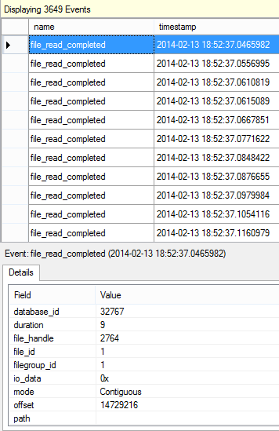

There is also the built-in system\_health session started automatically at SQL Server service start up, which provides useful information for performance troubleshooting

In this article, we presented the SQL Server performance monitoring utilities available in Windows and SQL Server. The information they provide and knowledge required to use them varies. Some of them, like Activity Monitor, are easy to use and require no coding, but at the same time provide only basic information useful just to get the general picture. On the other hand, Extended Events can monitor and handle various run-time errors, resource bottlenecks, blocking, etc. But to get the most of them, coding is required

Resources  
[SQL Server Profiler](http://technet.microsoft.com/en-us/library/ms181091.aspx)  
[SQL Trace](http://technet.microsoft.com/en-us/library/hh245121.aspx)  
[Dynamic Management Views and Functions (Transact-SQL)](http://technet.microsoft.com/en-us/library/ms188754.aspx)  
[Extended Events](http://technet.microsoft.com/en-us/library/bb630282.aspx)  
[View Event Session Data](http://technet.microsoft.com/en-us/library/hh710068.aspx)

[](http://www.apexsql.com/sql_tools_monitor.aspx?utm_source=sqlshack&utm_medium=banner&utm_campaign=%5BSQLShack%5DApexSQLMonitor&utm_content=728x90)

[](http://www.sqlshack.com/author/milenapetrovic/)

[Milena Petrovic](http://www.sqlshack.com/author/milenapetrovic/)

Product Support Engineer at [ApexSQL software](http://www.apexsql.com/" \t "_blank)

Milena is a SQL Server professional with more than 20 years of experience in IT. She has started with computer programming in high school and continued at University. She has been working with SQL Server since 2005 and has experience with SQL 2000 through SQL 2014.Her favorite SQL Server topics are SQL Server disaster recovery, auditing, and performance monitoring.   
  
[View all posts by Milena "Millie" Petrovic](http://www.sqlshack.com/author/milenapetrovic/)

 9

  1

Related Posts:

1. [A DBA guide to SQL Server performance troubleshooting – Part 1 – Problems and performance metrics](http://www.sqlshack.com/dba-guide-sql-server-performance-troubleshooting-part-1-problems-performance-metrics/)
2. [SQL Server alerts in troubleshooting performance issues: SQL Server alerting basics](http://www.sqlshack.com/sql-server-alerts-troubleshooting-performance-issues-sql-server-alerting-basics/)
3. [SQL Server performance tuning using Windows Performance Monitor](http://www.sqlshack.com/sql-server-performance-tuning-using-windows-performance-monitor/)
4. [SQL Server performance basics](http://www.sqlshack.com/sql-server-performance-basics/)
5. [SQL Server performance monitoring with Data Collector](http://www.sqlshack.com/sql-server-performance-monitoring-data-collector/)

[SQL Server performance tuning](http://www.sqlshack.com/sql-server-performance-tuning/)

**0 comments**

[**[http://zor.fyre.co/wjs/v3.0.1410389091/images/down_arrow.pngLivefyre](http://livefyre.com/)**](http://livefyre.com/)

Sign in or Post as Guest

**6 people listening**

+ Follow

Share

**Post comment as...**

Newest | Oldest | Top Comments

[](http://www.apexsql.com/free/?utm_source=sqlshack&utm_medium=banner&utm_content=Free-Sharky&utm_campaign=%5BSQLShack%5DFree-Tools)

Categories

* [Business Intelligence](http://www.sqlshack.com/business-intelligence/) (6)
* [SQL Commands](http://www.sqlshack.com/sql-commands/) (1)
* [SQL Database design](http://www.sqlshack.com/sql-database-design/) (1)
* [SQL Recovery](http://www.sqlshack.com/sql-recovery/) (8)
* [SQL Server 2012](http://www.sqlshack.com/sql-server-2012/) (4)
* [SQL Server Cursors](http://www.sqlshack.com/sql-server-cursors/) (2)
* [SQL Server maintenance](http://www.sqlshack.com/sql-server-maintenance/) (12)
* [SQL Server Management Studio](http://www.sqlshack.com/sql-server-management-studio/) (2)
* [SQL Server partitioning](http://www.sqlshack.com/sql-server-partitioning/) (1)
* [SQL Server performance tuning](http://www.sqlshack.com/sql-server-performance-tuning/) (44)
* [SQL Server security](http://www.sqlshack.com/sql-server-security/) (11)
* [SQL Transaction Log](http://www.sqlshack.com/sql-transaction-log/) (5)
* [SSIS packages](http://www.sqlshack.com/ssis-packages/) (3)

Popular

* [10 most important SQL Server transaction log myths](http://www.sqlshack.com/10-important-sql-server-transaction-log-myths/)
* [SQL Server memory performance metrics – Part 1 – Memory pages/sec and Memory page faults/sec](http://www.sqlshack.com/sql-server-memory-performance-metrics-part-1-memory-pagessec-memory-page-faultssec/)
* [SQL Server Activity Monitor](http://www.sqlshack.com/sql-server-activity-monitor/)
* [SQL Server memory performance metrics – Part 2 – available bytes, total server, and target server memory](http://www.sqlshack.com/sql-server-memory-performance-metrics-part-2-available-bytes-total-server-target-server-memory/)
* [SQL Server memory performance metrics – Part 5 – understanding Lazy Writes, Free List Stalls/sec, and Memory Grants Pending](http://www.sqlshack.com/sql-server-memory-performance-metrics-part-5-understanding-lazy-writes-free-list-stallssec-memory-grants-pending/)
* [SQL Server memory performance metrics – Part 4 – Buffer Cache Hit Ratio and Page Life Expectancy](http://www.sqlshack.com/sql-server-memory-performance-metrics-part-4-buffer-cache-hit-ratio-page-life-expectancy/)
* [SQL Server performance monitoring with Data Collector](http://www.sqlshack.com/sql-server-performance-monitoring-data-collector/)
* [Using SSIS packages to import MS Excel data into a database](http://www.sqlshack.com/using-ssis-packages-import-ms-excel-data-database/)
* [SQL Server performance monitoring with Data Collector – Part 3 – reading the reports](http://www.sqlshack.com/sql-server-performance-monitoring-data-collector-part-3-reading-reports/)
* [A beginner’s guide to SQL Server transaction logs](http://www.sqlshack.com/beginners-guide-sql-server-transaction-logs/)
* [Top 10 articles on the SQL Server transaction log](http://www.sqlshack.com/top-10-articles-sql-server-transaction-log/)
* [Ways to use and execute SQL Server Integration Services packages](http://www.sqlshack.com/ways-use-execute-sql-server-integration-services-packages/)
* [SQL Server performance basics](http://www.sqlshack.com/sql-server-performance-basics/)
* [SQL Server performance monitoring with Data Collector – Part 2 – set-up and usage](http://www.sqlshack.com/sql-server-performance-monitoring-data-collector-part-2-set-up-and-usage/)
* [A DBA guide to SQL Server performance troubleshooting – Part 1 – Problems and performance metrics](http://www.sqlshack.com/dba-guide-sql-server-performance-troubleshooting-part-1-problems-performance-metrics/)
* [SQL Server memory performance metrics – Part 3 – SQL Server Buffer Manager metrics and memory counters](http://www.sqlshack.com/sql-server-memory-performance-metrics-part-3-sql-server-buffer-manager-metrics-memory-counters/)
* [Database table partitioning in SQL Server](http://www.sqlshack.com/database-table-partitioning-sql-server/)
* [SQL Server query execution plans – Understanding and reading the plans](http://www.sqlshack.com/sql-server-query-execution-plans-understanding-reading-plans/)
* [SQL Server query execution plans – Viewing the plans](http://www.sqlshack.com/sql-server-query-execution-plans-viewing-plans/)
* [SQL Server memory performance metrics – Part 6 – other memory metrics](http://www.sqlshack.com/sql-server-memory-performance-metrics-part-6-memory-metrics/)

Sponsored

* [Read a SQL Server transaction log](http://solutioncenter.apexsql.com/read-a-sql-server-transaction-log/)
* [SQL Server database auditing techniques](http://solutioncenter.apexsql.com/sql-server-database-auditing-techniques/)
* [How to recover SQL Server data from accidental UPDATE and DELETE operations](http://solutioncenter.apexsql.com/sql-server-data-recovery-from-update-and-delete/)
* [How to quickly search for SQL database data and objects](http://solutioncenter.apexsql.com/quickly-search-for-sql-database-data-and-objects/)
* [Synchronize SQL Server databases in different remote sources](http://solutioncenter.apexsql.com/synchronize-sql-server-databases-in-different-remote-sources/)
* [Recover SQL data from a dropped table without backups](http://solutioncenter.apexsql.com/rollback-drop-table-statement-without-backups/)
* [SQL Formatting standards – Capitalization, Indentation, Comments, Parenthesis](http://solutioncenter.apexsql.com/sql-formatting-standards-capitalization-indentation-comments-parenthesis/)
* [Recover deleted SQL data from transaction logs](http://solutioncenter.apexsql.com/recover-deleted-sql-data-from-transaction-logs/)
* [How to recover SQL Server data from accidental updates without backups](http://solutioncenter.apexsql.com/recover-sql-server-data-from-accidental-updates/)
* [Automatically compare and synchronize SQL Server data](http://solutioncenter.apexsql.com/automatically-compare-and-synchronize-sql-server-data/)
* [**About**](http://www.sqlshack.com/about-us/)

* [**Authors**](http://www.sqlshack.com/authors/)

Copyright © 2014 SQL Shack. Content is licensed under [CC-SA with attribution required](http://creativecommons.org/licenses/by-nc-nd/3.0/us/)

ShareThis Copy and Paste

- See more at: http://www.sqlshack.com/dba-guide-sql-server-performance-troubleshooting-part-2-monitoring-utilities/#sthash.1LB3C3Gf.dpuf